Part1
Create the following directory
- Create directory called documents
- Change to your documents directory and create 3 folders in the order given called( work, home, and misc)
- Take a listing of the document directory
- Clear the screen when finished.
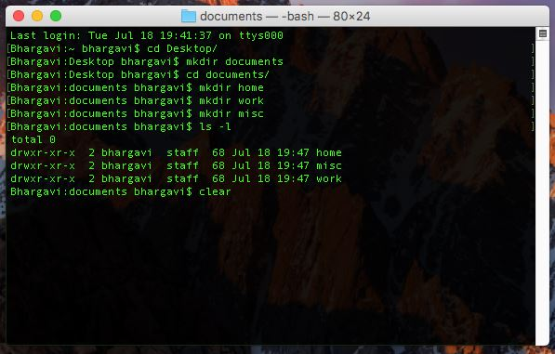

- I have created directory called documents.
- Then changed the directory using “cd” command.
- Created three directories work, home and misc.
- Took the list of directory documents.

Part 2
Go into the work directory and create a test file called links that contain the line “ This is the links file”
Use ctr+ c to save and close.
Cd work
Cat > links
Then put the statement “ This is the links file”

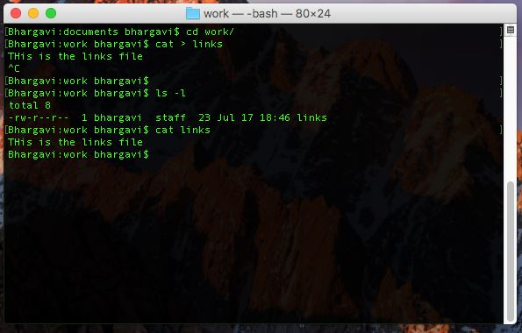

I have created new file called links called links using “Cat > links” command.
Cd links command is used to view the file called links.

Part3
View the Inode number of the links file create a Hard link to the links file called links2. View the Inode number of the files .
Work:/ ls -i
/ ln links links2
/ls -l
Question : report the numbers and comment on them.
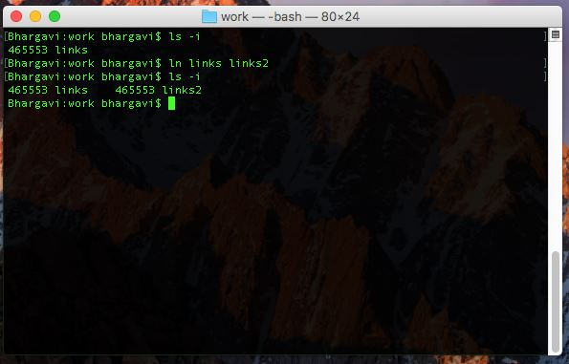
- Links: 465553 // Inode number.
- Links2: 465553 // Inode number.
- Inode number is same for both files.
- ln links links2 command is used to crate hard links “ln”.

Part 4
Append the links file with a directory listing of the work directory. View the contents of links and links2
/ls >> links
/cat links
Cat links2
Question: Report the result
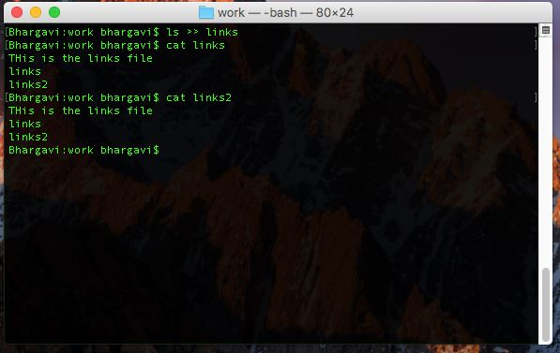
Is >> links is used to append the directory listing of the work directory .
Cat links is used to display the contents of the “file”.
Cat links2 is used to display the contents of the “file2”.
We have the same content in both the files as links is hard linked to links2.

Part5
Append the links2 file with a directory listing of the dlinksocuments directory. View the contents of links and links2
/ls .. >> links2
/cat links
/cat links2
Question : Compare the files and comment on the result
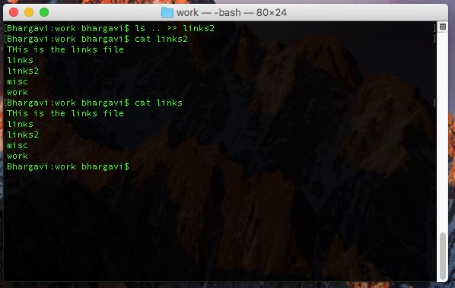
Is.. >> links2 is used to append the directory listing of the previous directory i.e., document directory.
Cat links2 display the contents of the file “links2”.
- Both files have the same inode number because link file is hard linked to the links2, so will contain the same data.

Part 6
Delete the original links file Note that the file links2 still exists. Create a symbolic link to links3 from links2
Work/rm links
/ ln –s
/cat links2
Question : Report the result
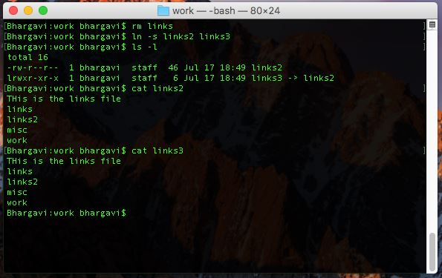

Rm links this command is used to remove the file “links” from the filesystem.
Ln – s this command used to create a symbolic link.
Here we are trying to create symbolic link between “link2” and “link3”.
Ln-s link2 link3 this command is used to create symbolic link between link2 and link3.
Ls-I this command is used to the list the contents of the current directory i.e., work.

Part 7
Append the links3 file with a directory listing of the work directory view the contents of links2 and links3. Remove the links2 file. View contents of links 3 . Type ls –l. Clear the screen

/ls >> links3
/cat links2
/cat links 3
Compare and report the result
/rm links2
/Cat links3
Question : Report and comment of the result
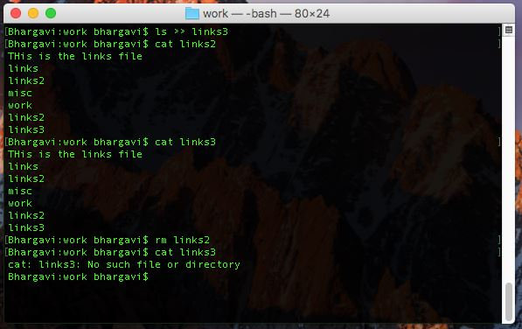

Is>> link3 this command appends the directory listing of the current working directory into the file.
Cat links3 this command is used to display the contents of the file “links3”.
Cat links2 this command is used to display the contents of the file “links2”.
Links3 is soft linked to the links2, we have the same contents in both links2 and links3.
Rm links2 this command is used to remove the file “links2”.
- Links2 file was removed from the system, so links3 will not accessed as it was symbolic linked to the links2 file .

